|  |  |
| --- | --- |
| **Computer Science 1** | **Lab 08B**  **Practice/Perform Major Python Assignment** |
| **Repetition with Traditional Graphics** | **50, 60, 70, 80, 90, 100 & 110 Point Versions** |
| **Assignment Purpose:**  The purpose of this program is to reinforce understanding of using repetition control structures, like the **for** loop, visually using *Traditional Graphics*. | |

For this lab assignment you are provided with a grid of two rows by four columns. Each cell in the grid needs some graphics object to be drawn. It will be necessary to use procedures from the **Graphics**library to complete this assignment. The use of the grid is intentional. One cell will be done for you as an example. In the other 7 cells you will need to display some type of shape multiple times. Please realize that **A REPETITION CONTROL STRUCTURE MUST BE USED!** For example, one cell has 15 concentric circles. You are **NOT** allowed to simply type 15 **drawCircle** commands. You need one **drawCircle** command inside a **for** loop that will make it repeat 15 times.

|  |  |
| --- | --- |
| **Lab 08B Student Version** | **Do not copy this file, which is provided.** |
| **1 # Lab08Bst.py  2 # "Repetition With Traditional Graphics"  3 # This is the student, starting version of Lab 08B.  4   5   6 from Graphics import *  7   8 beginGrfx(1300,700)  9  10 # Substitute your own name here. 11 drawHeading("John Smith","8B") 12  13 # Draw Grid 14 drawLine(325,50,325,700) 15 drawLine(650,50,650,700) 16 drawLine(975,50,975,700) 17 drawLine(1300,50,1300,700) 18 drawLine(0,375,1300,375) 19 drawLine(0,700,1300,700) 20  21 # Draw Red Horizontal Lines 22 setColor("red") 23 x1 = 0 24 y1 = 55 25 x2 = 325 26 y2 = 55 27 for k in range(32): 28 drawLine(x1,y1,x2,y2) 29 y1 += 10 30 y2 += 10 31  32  33 # Draw Blue Vertical Lines 34  35  36  37  38  39  40 # Draw Magenta Diagonal Dots 41  42  43  44  45  46  47 # Draw Green Concentric Circles 48  49  50  51  52  53  54 # Draw Purple Concentric Ovals 55  56  57  58  59  60  61 # Draw Brown Concentric Squares 62  63  64  65  66  67  68 # Draw Black Concentric Regular Polygons 69  70  71  72  73  74  75 # Draw Gold Sphere 76  77  78  79  80  81  82  83 endGrfx() 84** | |

**Current Output of Lab07Bst.py**

At the beginning, the output is a 4 by 2 grid, with the “Red Horizontal Lines” cell done for you.

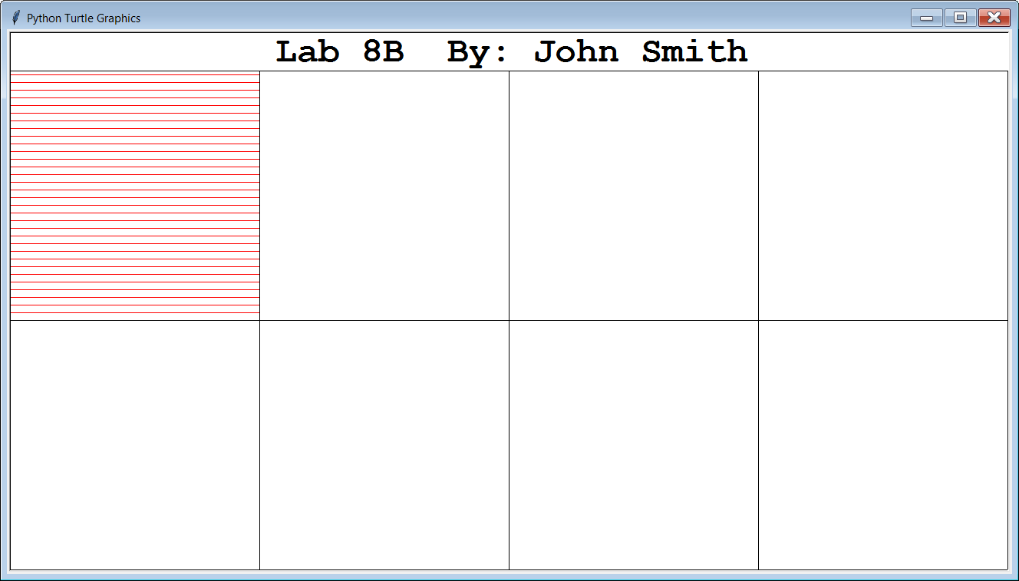

**50, 60, 70, 80, 90, 100 & 110-Point Version Specifics**

The 110-point version is shown on the next page and displays ALL 8 cells.

The 100-point version displays 7 of the 8 cells (Red Horizontal Lines, and 6 others).

The 90-point version displays 6 of the 8 cells (Red Horizontal Lines, and 5 others).

The 80-point version displays 5 of the 8 cells (Red Horizontal Lines, and 4 others).

The 70-point version displays 4 of the 8 cells (Red Horizontal Lines, and 3 others).

The 60-point version displays 3 of the 8 cells (Red Horizontal Lines, and 2 others).

The 50-point version displays 2 of the 8 cells (Red Horizontal Lines, and 1 other).

**110-Point Version Output**

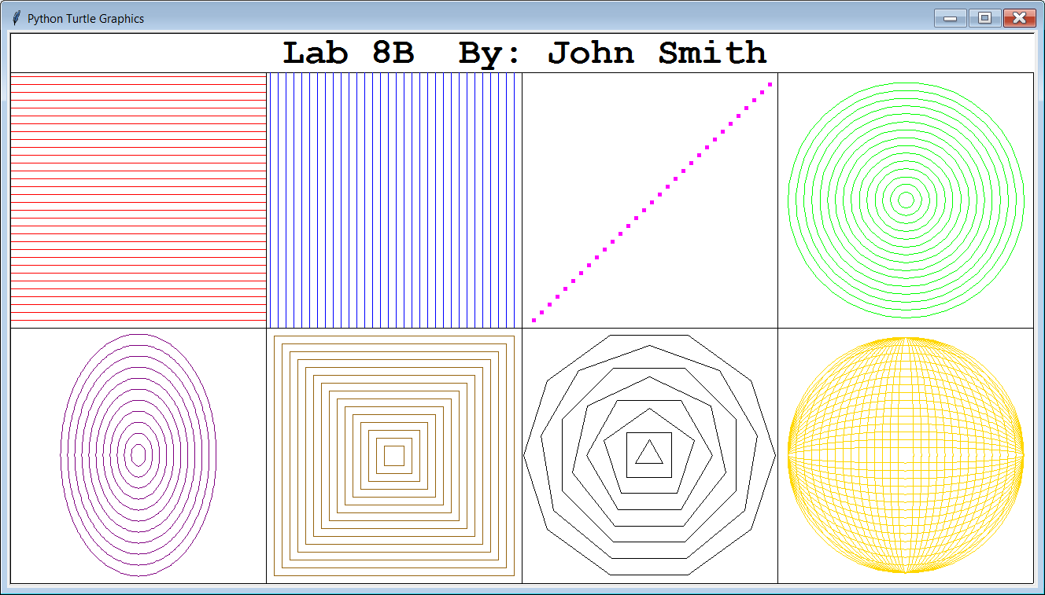

NOTE: You can do these in any order you wish, but the *Golden Sphere* is the hardest, so it is recommended that you do that cell last.